CAPP each document, then answer the following for each document.
To what extent does EACH document show the Articles as an effective government? Provide evidence to support your answers.

DOCUMENT 1

THE RESOLUTION ON PUBLIC LANDS
October 10, 1780

Resolved, that the unappropriated lands that may be ceded or relinquished to the United States, by an particular States, pursuant to the recommendation of Congress on the 6th day of September last, shall be disposed of for the common benefit of the United States, and be settled and formed into distinct republican States, which shall become member of the Federal Union, and shall have the same rights of sovereignty, freedom and independence as the other states . . .

That the necessary and reasonable expenses which any particular State shall have incurred since the commencement of the present war, in subduing any of the British posts, or in maintaining forts or garrisons within and for the defence, or in acquiring any part of the territory that may be ceded or relinquished to the United States, shall be reimbursed.

G. Hunt, ed., Journals of the Continental Congress. Washington. Government Printing Office, 1910, XVLLL, 915 in Feder, Bernard. Viewpoints USA. New York: American Book Company, 1967.

DOCUMENT 2

THE LAND ORDINANCE OF 1785

. . . the territory ceded by individual states to the United States, which has been purchased from the Indian inhabitants, shall be disposed of in the following manner:

. . . The Surveyors . . . shall proceed to divide the said territory into townships of six miles square by lines running due north and south and others crossing these at right angles, as near as may be . . .

The plats {maps} of the townships, respectively, shall be marked by subdivisions into lots of one mile square, or 640 acres . . .

There shall be reserved for the United States out of every township . . . four lots . . .There shall be reserved the lot No. 16 of every township for the maintenance of public schools within the said township . . .

W.C. Ford, ed., Journals of the Continental Congress, 1774-1789. Washington. Government Printing Office, 1933, XVIII, 375-378 in Feder, Bernard. Viewpoints USA. New York: American Book Company, 1967.

DOCUMENT 2 MAP

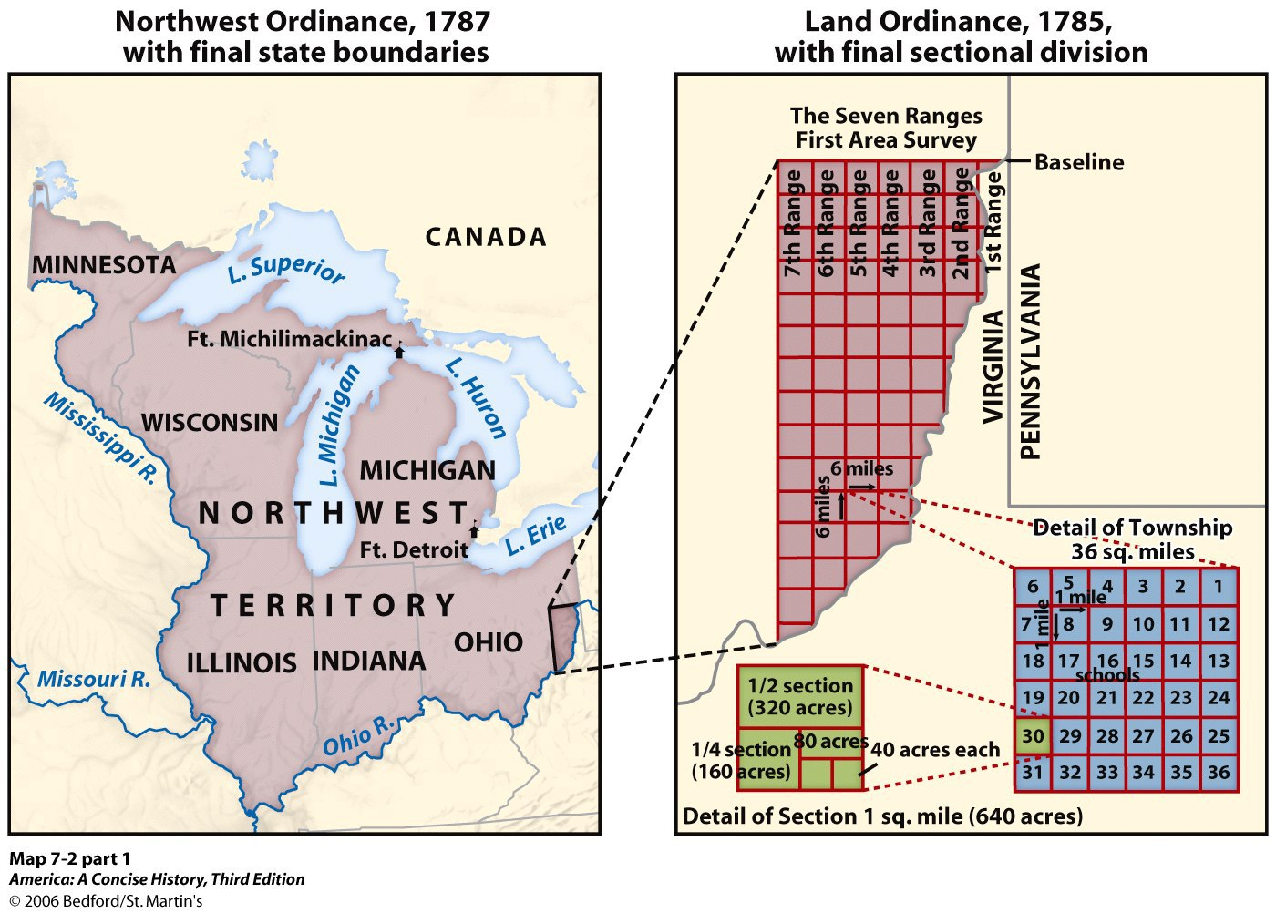

DOCUMENT 3

THE NORTHWEST ORDINANCE OF 1787

It is hereby ordained and declared by the authority aforesaid that the following articles shall be considered as articles of compact between the original states and the people and states in the said territory, and forever remain unalterable unless by common consent, to wit:

Article 1. No person, demeaning [conducting] himself in a peaceable and orderly manner, shall ever be molested on account of his mode of worship or religious sentiments in the said territory.

Article 2. The inhabitants of the said territory shall always be entitled to the benefits of the writ of habeas corpus and of the trial by jury; of a proportionate representation of the people in the legislature; and of judicial proceedings according to the course of the common law. . .

Article 3. Religion, morality, and knowledge being necessary to good government and the happiness of mankind, schools and the means of education shall forever be encouraged . . .
The utmost good faith shall always be observed towards the Indians; their lands and property shall never be taken from them without their consent; and in their property, rights and liberty they never shall be invaded or disturbed, unless in just and lawful wars authorized by Congress; but laws founded in justice and humanity shall, from time to time, be made, for preventing wrongs being done to them, and for preserving peace and friendship with them.

Article 4 . . . The navigable waters leading into the Mississippi and St. Lawrence, and the carrying places between the same, shall be common highways and forever free . . .

Article 5. There shall be formed in the said territory, not less than three nor more than five states; . . . And, whenever any of the said states shall have sixty thousand free inhabitants therein, such state shall be admitted by its delegates into the Congress of the United States on an equal footing with the original states in all respects whatever, and shall be at liberty to form a permanent constitution and state government: Provided the constitution and government to be formed shall be republican . . .

Article 6. There shall be neither slavery nor involuntary servitude in the said territory, otherwise than in punishment of crimes whereof the party shall have been duly convicted . . .

Ford, Journals of the Continental Congress, 1774-1789, XXXII, 337-39 in Feder, Bernard. Viewpoints USA. New York: American Book Company, 1967.

DOCUMENT 4

THE STATE OF FRANKLIN

Introduction: Land was turned over to the United States by North Carolina, and then taken back. Governor Alexander Martin, facing a revolt in the western counties, sends a warning to the inhabitants of the self-proclaimed State of Franklin.

To the Inhabitants of the Counties of Washington, Sullivan and Greene:
A MANIFESTO

Whereas, I have received letters from Brigadier-General Sevier, under the style and character of Governor, and from Messrs. Landon Carter and William Cage, as Speakers of the Senate and House of Commons of the State of Franklin, informing me that they, with you, the inhabitants of part of the territory lately ceded to Congress, had declared themselves independent of the State of North Carolina . . . stating their reason for their separation and revolt – among which it is alleged, that the western country was ceded to Congress without their consent, by an act of the legislature, and the same was repealed in the like manner . . .

I have thought proper to issue this Manifesto, hereby warning all persons concerned in the said revolt, that they return to their duty and allegiance, and forbear paying any obedience to any self-created power and authority unknown to the constitution of the state and not sanctified by the Legislature . . .

J.G. M. Ramsey, The Annals of Tennessee. Charleston. J. Russell, 1853, 309 ff. in Feder, Bernard. Viewpoints USA. New York: American Book Company, 1967.

DOCUMENT 4: MAP OF THE LOST STATE OF FRANKLIN (1784)

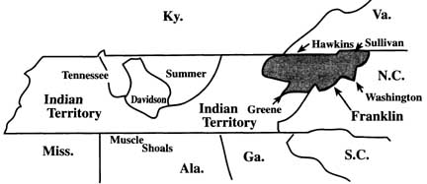

Map from Dave Foster’s Franklin, the Stillborn State and the Sevier/Tipton Political Feud

DOCUMENT 5

WHAT WERE OUR RELATIONS WITH EUROPE?

Introduction: This excerpt was written by John Baker Holroyd of Great Britain, the Earl of Sheffield.

. . . it may reasonably be a question, whether the trade ever will be again so prosperous a state for America. Confusion and anarchy are likely to prevail for some time. Our descendants, the New Englanders, apt to be troublesome to themselves as well as to others . . . may assume a tone which . . . will now avail them little in Europe . . . The weakness of the Southern States has not a little to fear from their interference. It remains to be seen whether the southern will become the puppets of the northern, whether the Middle Colonies will be the dupes to the northern or a barrier to the Southern States . . .

It will be a long time before the American States can be brought to act as a nation, neither are they to be feared as such by us . . .

At present, the only part Britain should take is most simple and perfectly sure. If the American States chuse to send Consuls, receive them, and send a Consul to each State. Each State will soon enter into all necessary regulations with the Consul, and this is the whole that is necessary.
John Baker Holroyd, Earl of Sheffield, “Observations on the Commerce of the American States,” 1783, in A.B. Hart, American History Told by Contemporaries. New York, Macmillan (1928) 1961, III, 165-166 in Feder, Bernard. Viewpoints USA. New York: American Book Company, 1967.

DOCUMENT 6

LETTER FROM JOHN F. SACKVILLE, DUKE OF DORSET, TO THE AMERICAN COMMISSIONERS

Introduction: John Adams, Benjamin Franklin, and Thomas Jefferson, the American Commissioners, had asked the English government to negotiate a trade treaty. This document was the response to their request.

. . . you declared yourselves to be fully authorized and empowered to negotiate [and] I have been, in answer thereto, instructed to learn from you gentlemen, what is the real nature of the powers with which you are invested, whether you are merely commissioned by Congress, or whether you have received separate powers from your respective States. A committee of North American merchants have waited upon his Majesty’s principal Secretary of State for foreign affairs to express how anxiously they wished to be informed upon this subject, repeated experience having taught them in particular, . . how little the authority of Congress could avail . . . where the interest of any one individual State was even concerned.

The apparent determination of the respective States to regulate their own separate interests renders it absolutely necessary . . . that my Court should be informed how far the Commissioners can be duly authorized to enter into any engagements with Great Britain, which it may not be in the power of any one of the States to render totally fruitless and ineffectual.

Letter from J.F. Sackville, March 26, 1785. Diplomatic Correspondence of the United States of America, 1783-1789. Washington, 1833, II, 297-98 in Feder, Bernard. Viewpoints USA. New York: American Book Company, 1967.
DOCUMENT 7

NOAH WEBSTER, WRITING IN SKETCHES OF AMERICAN POLICY
(1785)

Introduction: Noah Webster, Jr. (1758-1843) was an American lexicographer, textbook pioneer, English-language spelling reformer, political writer, editor, and author.

The American States as to their general internal policies are not united; there is no supreme power at their head; they are in a perfect state of nature and independence as to each other; each is at liberty to fight its neighbor, and there is no sovereign to call forth the powers of the continent to quell the dispute or punish the aggressor . . . the whole is . . . the jest and ridicule of the world.

DOCUMENT 8

An excerpt from FEDERALIST 15
Alexander Hamilton

We may . . . be said to have reached almost the last stage of national humiliation. There is scarcely any thing that can wound the pride or degrade the character of an independent nation which we do not experience . . . Do we owe debts to foreigners and to our own citizens . . . ? These remain without any proper or satisfactory provision for their discharge. Have we valuable territories and important posts in the possession of a foreign power which, by express stipulations, ought long since to have been surrendered? These are still retained . . . Are we in a condition to resent or to repel the aggression? We have neither troops, nor treasury, nor government . . . Are we entitled by nature and compact to a free participation in the navigation of the Mississippi? Spain excludes us from it . . . Is commerce of importance to national wealth? Ours is at the lowest point . . . Is respectability in the eyes of foreign powers a safeguard against foreign encroachments? The imbecility of our government even forbids them to treat [deal] with us. Our ambassadors abroad are the mere pageants of mimic sovereignty . . .

Federalist No. 15, 1787, The Federalist. New York. Random House [n.d.], 87-88 in Feder, Bernard. Viewpoints USA. New York: American Book Company, 1967.

