1. Introduction
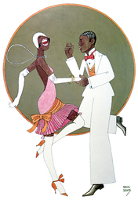
Bee Jackson, a New York City dancer, was looking for a chance to become famous. But she was only part of a Broadway musical chorus line, so no one really knew her. Then one night in 1923, Jackson went to see Runnin' Wild, the new African American musical everyone was talking about. The dancers began doing a dance she had never seen before called the Charleston. "I hadn't been watching it three minutes," Jackson later recalled, "before I recognized it as old Mrs. Opportunity herself shouting, 'Hey! Hey!'"
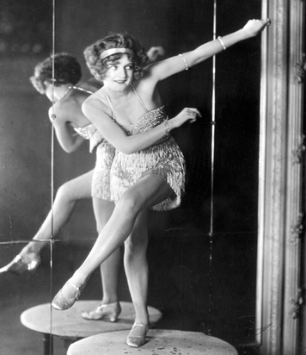
The Charleston began as an African American folk dance in the South. It got its name from the South Carolina city of Charleston. The dance migrated north to Harlem, an African American neighborhood in New York City. There, Elida Webb, the dance mistress for Runnin' Wild, saw it and adapted the dance for the musical. After seeing the Charleston onstage, Jackson asked Webb to teach it to her.
Jackson created a dance act for herself featuring the Charleston. A booking agent took one look at the act and said, "That dance is a hit. You can't keep quiet when you are watching it." He booked Jackson into a New York City nightclub known as the Silver Slipper. From there, she took her dance act on the road to other clubs around the country and then to London and Paris. As the dance craze spread, Jackson gained the fame she had always wanted.
Young people loved the Charleston. Its fast-paced music and swinging moves were a perfect fit for a time known as the Roaring Twenties. "The first impression made by the Charleston was extraordinary," wrote one observer. "You felt a new rhythm, you saw new postures, you heard a new frenzy in the shout of the chorus." Older Americans, however, were often shocked by the dance. At Smith College, students were not allowed to practice it in their dorm rooms. This conflict over a dance was a sign that American culture was changing, sometimes far faster than many people could or would accept.

2. Americans Buy into a Consumer Culture
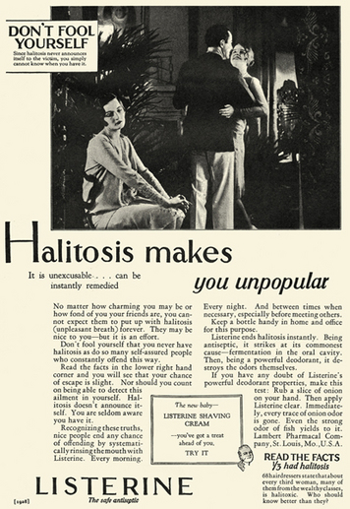
"How's your breath today?" Listerine ads from the 1920s often asked. "Don't fool yourself . . . Halitosis makes you unpopular." The ad might show a sophisticated couple gliding across the dance floor, face-to-face. Bad breath does not seem to be a problem for them. Be like them, the ad seems to say. "Halitosis doesn't announce itself. You are seldom aware you have it . . . Nice people end any chance of offending by . . . rinsing . . . with Listerine. Every morning. Every night."
In 1914, Listerine was introduced as the nation's first over-the-counter mouthwash. Until then, bad breath was something few people thought much about. Listerine advertisements changed that. Suddenly people began to worry about "halitosis"—an obscure medical term for bad breath that Listerine's makers popularized. "Halitosis spares no one," ads warned. "The insidious [quietly harmful] thing about it is that you yourself may never realize when you have it." Listerine sales skyrocketed. In just seven years, the product's sales revenues rose into the millions—all thanks to the power of advertising.

New Products Promise to Make Life Easier
At the root of the Listerine ad was a promise. Use Listerine every day, and your life will get better. In the 1920s, the makers of other new products repeated such promises in radio and print advertisements. In the process, they helped create a new consumer culture. This is a culture that views the consumption of large quantities of goods as beneficial to the economy and a source of personal happiness.
The ideas for some new products emerged from brilliant minds. George Washington Carver, for example, pioneered the creation of new goods based on agricultural products. Carver made more than 300 products from peanuts, including a face powder, printer's ink, and soap. He also created more than 75 products from pecans and more than 100 products from sweet potatoes, such as flour, shoe polish, and candy. "Anything will give up its secrets if you love it enough," Carver said of his work with humble plants.
In 1919, Charles Strite invented the pop-up toaster because he was tired of being served burnt toast in a company cafeteria. The appliance was a huge success. Clarence Birdseye, with an investment of $7 in an electric fan, buckets of saltwater, and cakes of ice, invented a system of flash-freezing fresh food in 1923.
The electrification of homes spurred the introduction of a host of new household appliances. Electric vacuum cleaners made cleaning easier. Electric-powered washing machines and irons revolutionized laundry day. Food preparation became easier with electric refrigerators and stoves.

Advertising Builds Consumer Demand
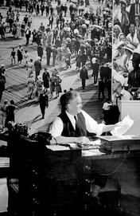
New kinds of advertisements created demand for these new products. No longer was it enough to say what the product was and why it was good. Now advertisers used psychologists to tailor their ads to people's desires and behaviors. In 1925, economist Stuart Chase observed,
Advertising does give a certain illusion, a certain sense of escape in a machine age. It creates a dream world: smiling faces, shining teeth, school girl complexions, cornless feet, perfect fitting union suits, distinguished collars, wrinkleless pants, odorless breaths, . . . charging motors, punctureless tires, . . . self-washing dishes.
—Stuart Chase, "The Tragedy of Waste," The Atlantic Monthly, 1925
Businesses found that by changing styles frequently, they could induce consumers to buy their goods more often. Women had already accepted the ups and downs of hemlines. Now the practice of introducing new models every year was extended to goods that were supposed to last a long time, including cars, furniture, and household appliances. Advertisers worked hand-in-hand with businesses to convince consumers of the value of staying up-to-date. Buying the latest model, even if you didn't need it, became a sign of prestige.
Bruce Barton was the most famous adman of the time. In 1925, he published a book titled The Man Nobody Knows. In it, he praised Jesus as the founder of a successful business, saying, "He picked up twelve men from the bottom ranks of business and forged them into an organization that conquered the world." In Barton's view, "Jesus was a real executive . . . a great advertising man. The parables are the greatest advertisements of all time." Barton's "irreverent" and controversial book topped the nonfiction best-seller list in 1925, selling more than 750,000 copies by 1928.

Americans Begin to Buy Now, Pay Later
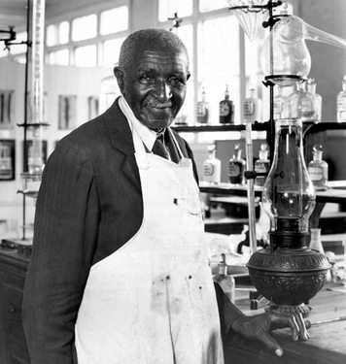
In the 1920s, Americans achieved the highest standard of living in the world. Still, many consumers could not afford all the goods they wanted and thought they needed. One reason was that the new products often cost far more than the older ones they were replacing. An electric washing machine cost much more than an old-fashioned washboard. The same was true of an electric shaver compared with a safety razor.
The expansion of credit made it possible for consumers to buy what they wanted, even when they lacked enough cash. Credit is an arrangement for buying something now with borrowed money and then paying off the loan over time. In the past, most Americans had thought it shameful to borrow money to buy consumer goods. Thrifty people saved the money they needed and paid cash. By the 1920s, however, such thrift began to seem old-fashioned.
The growth of installment buying made it possible for Americans to buy goods on credit. In installment buying, a buyer makes a down payment on the product. The seller loans the remainder of the purchase price to the buyer. The buyer then pays back the loan in monthly installments. If the buyer stops making payments before the loan is repaid, the seller can reclaim the product.
By the end of the 1920s, about 15 percent of all retail sales were on installment plans. This included about three out of every four radios and six out of every ten cars. Buying on credit was so easy that many Americans began to think the good times would go on forever.

3. Americans Take to the Air and Roads
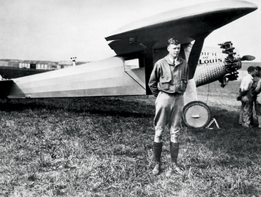
On May 20, 1927, a little-known airmail pilot from Minnesota took off on an extraordinary journey. Charles Lindberg was competing for the Orteig Prize—$25,000 for the first nonstop flight from New York City to Paris. He packed sandwiches, two canteens of water, and 451 gallons of gas. Lindbergh hit storm clouds and thick fog over the Atlantic that forced him at times to barely skim the ocean waves. The sun set as he drew near France. He later wrote,
I first saw the lights of Paris a little before 10 P.M…and a few minutes later I was circling the Eiffel Tower at an altitude of about four thousand feet…The lights of Le Bourget [airfield] were plainly visible…I could make out long lines of hangers, and the roads appeared to be jammed with cars.
—Charles Lindbergh, The Spirit of St. Louis, 1953
When Lindbergh landed, 100,000 people were waiting to greet him. Overnight, he had become the biggest celebrity of the decade. That "Lucky Lindy" did not seem to care about such adulation only endeared him more to the public.

Airplanes Give Americans Wings
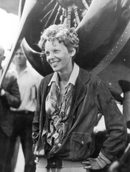
Airplanes had proven their usefulness during World War I. After the war, the U.S. government offered thousands of surplus warplanes for sale at bargain prices. Made of wood and canvas, these planes were not all that safe. Still, many wartime pilots bought the planes and used them for an exciting but dangerous style of flying called barnstorming.
Barnstormers toured the country, putting on daring air shows at county fairs and other events. They wowed audiences by flying planes in great loops and spirals. "Wing walkers" risked death by walking from wingtip to wingtip of a plane while it was in flight. Others leaped from the wing of one flying plane to another. Many of the planes crashed, and a number of barnstormers were killed. Lindbergh was one of the lucky barnstormers to live to old age.
The U.S. Post Office also bought surplus military planes to fly mail between a few large cities. The first transcontinental airmail route was opened between New York and San Francisco in 1920. Airmail greatly aided the growth of commercial aviation. Meanwhile, engineers were working to design safer, more powerful transport planes. By 1926, Henry Ford was producing an all-metal airplane powered by three engines rather than one. The Ford Tri-Motor could carry 10 passengers at speeds of 100 miles per hour.
In the early days of flight, pilots became celebrities. Adoring fans welcomed Lindbergh back from France with a ticker-tape parade in New York City, showering him with 1,800 tons of stockbrokers' ticker tape and confetti. In 1932, Amelia Earhart became the first woman to fly solo across the Atlantic. Congress awarded her the Distinguished Flying Cross. At the medal ceremony, she said her flight had proven that men and women were equal in "jobs requiring intelligence, coordination, speed, coolness, and willpower."

Automobiles Reshape American Life
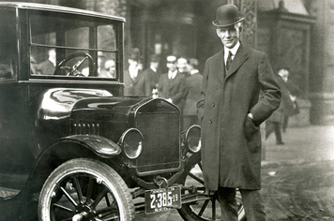
By making cars affordable, automaker Henry Ford had changed the way Americans lived. Cars quickly became more than just another means of transportation. A car gave women and teenagers a new sense of freedom. It ended the isolation of farmers. It made travel to far-away places enjoyable. By the late 1920s, Americans owned more cars than bathtubs. As one woman explained, "You can't drive to town in a bathtub."
The automobile changed where Americans lived. Urban workers no longer had to live within walking distance of their workplace or near a streetcar line to get to work. Suburbs began to spread farther around cities as people found it easier to travel to and from work by car. In the 1920s, for the first time in the nation's history, suburbs grew more quickly than cities.
Before cars became popular, most roads were dirt tracks. When it rained, automobiles sometimes sank to their hubcaps in mud. Motorists often had to wait days for mud to dry before they could move on. The Federal Highway Act of 1916 encouraged states to create highway departments to address this problem. Congress passed another highway act in 1921 to support road building.
As highways crept across the continent, new businesses took root beside them. Gas stations, diners, campgrounds, and motels sprang up to serve the needs of the car traveler. Advertising billboards became common sights on roadsides. At the same time, death tolls from accidents rose. The number of people killed in automobile accidents each year increased from fewer than 5,000 before the 1920s to more than 30,000 by the 1930s. Historian Frederick Lewis Allen noted yet another change brought about by the car:
The automobile age brought a parking problem that was forever being solved and then unsolving itself again. During the early nineteen-twenties the commuters who left their cars at the suburban railway stations at first parked them at the edge of the station drive; then they needed a special parking lot, and pretty soon an extended parking lot, and in due course, a still bigger one—and the larger the lot grew, the more people wanted to use it.
—Frederick Lewis Allen, The Big Change, 1952

4. Mass Media Shape American Popular Culture
Adoring fans worshipped movie star Rudolph Valentino as the "Great Lover." When he died suddenly at the age of 31, more than 100,000 people lined New York City streets to witness his funeral. It was an astonishing send-off for an Italian immigrant who had come to New York as a teenager in 1913. It was also a sign that Valentino had become an important part of his adopted country's popular culture. Popular culture is the culture of ordinary people and includes their music, art, literature, and entertainment. Popular culture is shaped by industries that spread information and ideas, especially the mass media.
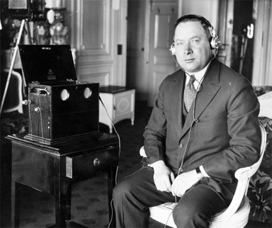

Print Media Bring Popular Culture to a National Audience
Newspapers and magazines had long been sources of information for Americans. During the 1920s, the amount of printed material available expanded enormously. By 1929, Americans were buying more than 200 million copies a year of popular national magazines, such as the Saturday Evening Post, Ladies' Home Journal, Reader's Digest, and Time.
As newspaper and magazine circulation increased, more and more people read the same stories, learned of the same events, and saw the same ideas and fashions. As a result, a popular culture common to all regions of the United States began to take shape. At the same time, regional differences that had once divided Americans began to fade in importance.

Radio Gives Popular Culture a Voice
Radio burst onto the American scene in the 1920s. Like newspapers and magazines, radio was a mass medium that could reach very large audiences. Suddenly, popular culture had a voice.
Radio station KDKA in Pittsburgh, Pennsylvania, is thought to be the first commercial radio station. When it broadcast the results of the 1920 presidential election, people began to have an inkling of what this new medium could do. As a result, radio sales took off.
Radio pioneer David Sarnoff had a huge impact on the development of broadcast radio. Sarnoff, a Jewish immigrant from Russia, began working for the Marconi Wireless Telegraph Company in 1906. Radio was first called the "wireless," because it received signals through the air rather than over wires, as the telephone did. On April 14, 1912, Sarnoff picked up a message relayed to New York City by ships at sea. It read, "Titanic ran into iceberg, sinking fast." For the next 72 hours, he stayed at his post, relaying the names of survivors to anxious relatives as the disaster at sea unfolded.
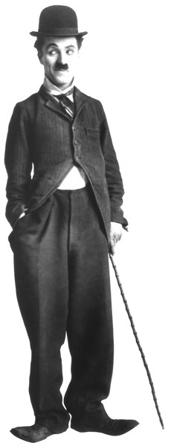
In 1919, Radio Corporation of America (RCA), a company that built radios, bought Marconi Wireless. Sarnoff saw that for RCA to sell many radios, it had to invest in programming that people would want to hear. But this idea was not easy to promote. "The wireless music box has no imaginable commercial value," others argued. "Who would pay for a message sent to nobody in particular?" To prove them wrong, Sarnoff arranged the broadcast of the Dempsey-Carpentier boxing match in 1921. Public response to this event confirmed the power of radio broadcasting to reach large numbers of people.
Sarnoff then proposed that RCA form a nationwide broadcasting network. He saw this network as a collection of radio stations across the country that would share programming. His proposal led to the formation of the National Broadcasting Company, or NBC. Much later, Sarnoff applied his vision to another medium—television. In 1941, NBC made the first commercial television broadcast. By then, Sarnoff was president of NBC, where he was known to all as "the General."
People soon came to expect radio stations to broadcast national news, such as elections. Many stations also brought play-by-play accounts of sports events to their listeners. In addition, stations began to broadcast regular programs of music, comedy, and drama. A situation comedy called Amos 'n Andy became so popular that many people would not answer their phones during its weekly broadcast.

Motion Pictures Create Movie Stars and Fans
The movies, too, became a big business in the 1920s. Motion pictures were first developed in the 1890s. At that time, movies were silent. After World War I, people flocked to movie theaters, eager to escape the problems of the postwar recession. They drank in melodramatic love scenes, were thrilled by exciting fight scenes, and laughed at silly situations. Income from ticket sales rose from $301 million in 1921 to $721 million in 1929. Weekly attendance climbed from 50 million in 1920 to 90 million in 1929.
The discovery of how to add sound to movies revolutionized the motion picture industry. In 1927, The Jazz Singer became the first feature-length "talkie." It was an overnight hit. Dialogue became an important part of films, expanding the job of writers. While some silent-film stars adjusted to the new medium, a whole new group of stars were born.
Like radio, the movies changed popular culture in powerful ways. Movie stars became national celebrities. Fans worshipped stars such as Valentino. Actress Mary Pickford was called "America's Sweetheart." Motion pictures exposed Americans to new fashions, new hairstyles, and a loosening of the rules of social behavior. As one historian wrote, "Radio told the masses what to do, and movies showed them how to do it."

5. Women Move Toward Greater Equality
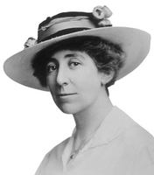
Some of the most significant social changes of the 1920s occurred in the lives of women. In 1920, the Nineteenth Amendment granted women the right to vote. That same year, women voted on a nationwide basis in a presidential election for the first time. For suffragists, this was a dream come true. Many had hoped that because women had worked for the vote as a group, they would also vote as a group. The "woman's vote," they argued, could bring an end to war, crime, and corruption in politics. But that did not happen. Once women won the right to cast ballots, they tended to make the same choices as their male relatives made.

Women Organize and Enter Politics
Many of the women who had worked so hard to gain the vote continued to be active in politics. Some formed a grassroots organization known as the League of Women Voters. A grassroots organization is created and run by its members, as opposed to a strong central leader. Members of the League of Women Voters worked to educate themselves and all voters on public issues.
Carrie Chapman Catt, a leader of the suffrage movement, saw that the vote alone would not gain women political power. The decisions that mattered most, she observed, were made behind a "locked door" by men. "You will have a long hard fight before you get behind that door," she warned, "for there is the engine that moves the wheels of your party machinery . . . If you really want women's votes to count, make your way there."
A few women did manage to get behind that door to run for public office. In 1917, Jeannette Rankin of Montana became the first woman elected to the House of Representatives. Two women—Nellie Tayloe Ross of Wyoming and Miriam Amanda Ferguson of Texas—became governors of their states in 1924. A year later, Representative Mae Ella Norton became the first woman to chair a congressional committee.

Women Lobby for Health Care and Equal Rights
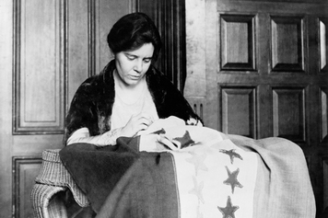
Women's groups also lobbied lawmakers to enact legislation of special interest to women. One of their concerns was the high death rate among new mothers and their infant children. In 1921, women persuaded Congress to pass the Sheppard-Towner Act. This act distributed federal funds to states to create health services for pregnant women, new mothers, and infant children. Despite fierce opposition, Congress enacted this law, in part because lawmakers wanted to appeal to new women voters.
Women's groups were less successful in other areas. In 1923, Alice Paul, representing the National Women's Party, persuaded two congressmen to introduce the equal rights amendment (ERA) to Congress. The intention of the ERA was to guarantee equal rights for all Americans, regardless of gender. It said simply, "Equality of rights under the law shall not be denied or abridged by the United States or by any State on account of sex."
Despite vigorous lobbying efforts, Congress did not approve the ERA that year. The amendment was reintroduced to Congress many times, always failing to win passage. Critics argued that the Constitution already guarantees equality under the law and that the amendment would abolish certain state and local laws concerning women. In 1972, Congress finally approved the ERA and sent it to the states for ratification. Over the next decade, however, not enough states gave their approval to add the ERA to the Constitution. Despite this setback, Paul's amendment has been reintroduced to Congress every term since 1982.

Women Seek New Opportunities and Freedom
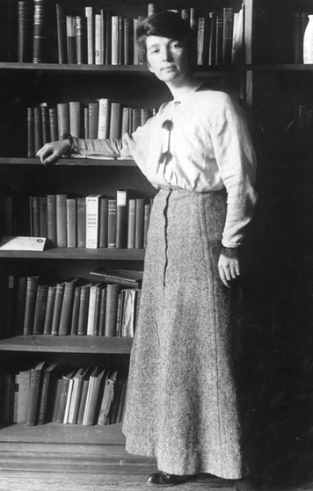
The 1920s brought expanded educational and job opportunities for women, in addition to their greater political rights. The number of women completing high school doubled during the decade. By the 1920s, one out of every four college faculty members was a woman. Women were entering many professions once open only to men. The number of women professionals rose by 50 percent by the end of the decade.
With wider opportunities and greater incomes, women, especially young women, rebelled against old customs. They cut their hair into short "bobs," a hairstyle easier to care for than the long hair of their mothers' generation. They also wore makeup. Lipstick, rouge, and eye shadow were no longer signs of an "immoral" woman. Women also began to wear shorter dresses. In 1919, skirts hovered 6 inches above the ground. By 1927, skirts no longer covered the knees.
Women's social behavior changed as their hemlines rose. Drinking alcohol and smoking in public were no longer socially unacceptable. In fact, they were signs of a "modern" woman. Family patterns also changed. Between 1914 and 1929, the number of divorces per year more than doubled.
The decline in birth rates was due in part to the pioneering work of Margaret Sanger. As a nurse caring for poor women in New York City, Sanger saw a link between family size and human misery. "Everywhere we look," she wrote, "we see poverty and large families going hand in hand." She also came to believe that women would never achieve equality with men unless they could choose when and if to bear children. "No woman can call herself free who does not own and control her body," she said. "No woman can call herself free until she can choose consciously whether she will or will not be a mother."
In 1916, Sanger opened the country's first family planning clinic, only to be arrested and jailed. At the time, distributing birth control information was illegal in every state. Sanger dedicated her life to altering those laws. She also founded what became the nation's leading family planning organization—the Planned Parenthood Federation of America.

6. African American Musicians Launch the Jazz Age
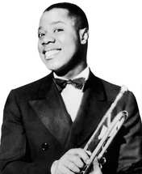
When Louis Armstrong arrived in New York City in 1924 to join Fletcher Henderson's band, the band members were not impressed. They took one look at Armstrong's long underwear and big clumpy boots and wondered if this was really the famed cornet player. On the first night that Armstrong played a solo with the band at the Roseland Ballroom, he was nervous as well. A fellow horn player encouraged him to "close your eyes and play what you feel . . . Just let it go . . . Be yourself . . . Forget about all the people." Armstrong did as he was told, and his music soared. The audience stopped dancing to gather around him. For months afterward, the Roseland was packed with people who couldn't get enough of Armstrong's playing.
Armstrong was a master of a new kind of music called jazz. Unlike more formal types of music, jazz was hard to define. As Armstrong once said, "If you have to ask what jazz is, you'll never know." This new music became so popular in the 1920s that this decade is often called the Jazz Age.

Jazz Grows Out of Blues and Ragtime
Jazz is a distinctly American musical form. It grew from a combination of influences, including African rhythms, European harmonies, African American folk music, and 19th-century American band music and instruments. At the turn of the 20th century, these forms began to mix and grew into blues and ragtime. The blues sprang from African American work songs, with elements of gospel and folk music. Many blues songs are about loneliness or sorrow, but others declare a humorous reaction to life's troubles. Ragtime used a syncopated, or irregularly accented, beat that gave the music a snappy, lilting feel.
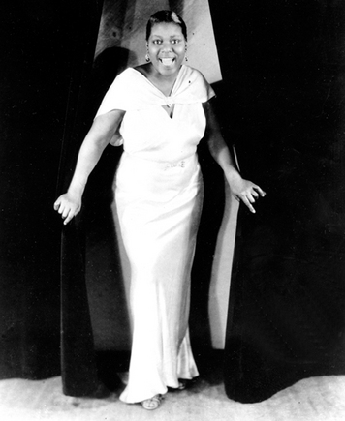
Jazz combined the syncopation of ragtime with the deep feelings of the blues. To this already rich mix, jazz musicians added improvisation. This is a process by which musicians make up music as they play rather than relying solely on printed scores. So, to some degree, the jazz musician is his or her own composer.
Jazz was born in New Orleans. There, African American musicians were in demand to play at funeral parades, in minstrel shows, and as part of riverboat orchestras. Many gifted but untrained black musicians did not know how to read music. They began to make up melodies and expand on familiar tunes. Eventually, the improvised solo became an integral element of jazz. The jazz pianist Duke Ellington said of improvisation, "It's like an act of murder; you play with intent to commit something."
As boats and then railroads traveled away from New Orleans, they carried the new music with them. Soon jazz caught fire in Kansas City, St. Louis, Los Angeles, Chicago, and New York City. Bandleader Paul Williams remembered,
One moment, jazz was unknown, obscure—a low noise in a low dive. The next it had become a serious pastime of a hundred million people, the diversion of princes and millionaires . . . The time was ripe . . . The whole tempo of the country was speeded up . . . Americans . . . lived harder, faster than ever before. They could not go without some new outlet . . . the great American noise, jazz.
—Paul Williams, quoted in Jazz: A History of America's Music, 2000

Night Clubs and Radio Bring Jazz to New Audiences
In the 1920s, the black population in New York City more than doubled as a result of migration from the South. The black migrants brought their love of jazz with them to the city, and the African American neighborhood of Harlem became a magnet for jazz lovers.
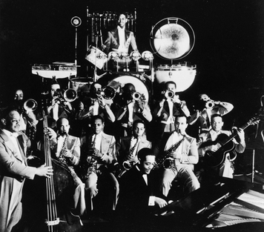
The number of nightclubs and jazz clubs in Harlem in the 1920s is estimated at anywhere from 500 to several thousand. Nearly all the great jazz musicians played there at some point. Harlem's most famous jazz club was the Cotton Club. The floorshow featured dancers in lavish costumes. The dancers and musicians were African American, but most of the patrons were white.
Although people could hear jazz at nightclubs in the cities, many first heard the new music on records. The first recordings of jazz were made in the 1910s. As the style gained popularity, many artists made records featuring their own work. Radio also helped spread jazz. In the late 1920s, the music of Duke Ellington and his band was broadcast nationwide from the Cotton Club. Benny Goodman, a white clarinetist, also had a popular band there. By 1929, a survey of radio stations showed that two thirds of airtime was devoted to jazz.

Jazz Becomes America's Music
By then it was clear that jazz was here to stay. Jelly Roll Morton became the first musician to write the new music down. Bandleader Duke Ellington composed jazz standards that are still played widely today. George Gershwin blended jazz with classical musical pieces like Rhapsody in Blue, which were written for full orchestras.
Young people, in particular, loved dancing to the new music. The Charleston and other dances swept the country. Unlike earlier forms of dancing, the new dances, with their kicks, twists, and turns, seemed wild and reckless. Many older Americans were shocked by jazz. They felt that its fast rhythms and improvisations were contributing to a loosening of moral standards. The Ladies' Home Journal even launched an anti-jazz crusade. Jazz, however, became the first uniquely American music to be played and loved around the world.

7. Writers and Artists in the 1920s
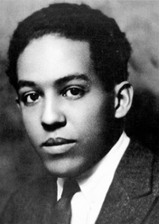
Young Langston Hughes had been living in Mexico with his father the year before he entered Columbia University. When he arrived in New York in 1921, his first stop was not his new college. Instead, Hughes headed to 135th Street, the heart of Harlem. He wrote of his arrival:
I came out on the platform with two heavy bags and looked around . . . Hundreds of colored people. I hadn't seen any colored people for so long . . . I went up the steps and out into the bright September sunlight. Harlem! I stood there, dropped my bags, took a deep breath and felt happy again.
—Langston Hughes, The Big Sea, 1940
For African American writers in the 1920s, Harlem was the place to be.

African Americans Create a "Harlem Renaissance"
The word renaissance means a "revival" or "rebirth." It usually describes a literary or artistic movement. The Harlem Renaissance was the outpouring of creativity among African American writers, artists, and musicians who gathered in Harlem during the 1920s. They shared their work and encouraged each other.
Many African American writers who were part of this movement explored what it meant to be black in the United States. Langston Hughes wrote poetry, plays, and fiction that captured the anguish of African Americans' longing for equality. He composed one of his best-known poems while traveling to New York at the age of 17.
I've known rivers:
I've known rivers ancient as the world and older than the flow of human
blood in human veins.
My soul has grown deep like the rivers.
I bathed in the Euphrates when dawns were young.
I built my hut near the Congo and it lulled me to sleep.
I looked upon the Nile and raised the pyramids above it.
I heard the singing of the Mississippi when Abe Lincoln went down to
New Orleans, and I've seen its muddy bosom turn all golden in the sunset.
I've known rivers:
Ancient, dusky rivers.
My soul has grown deep like the rivers.
—Langston Hughes, "The Negro Speaks of Rivers," 1920
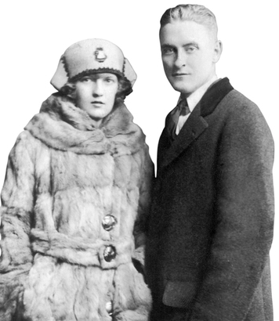
James Weldon Johnson broke new ground with his best-known book, The Autobiography of an Ex-Colored Man. The novel describes an attempt by an African American to escape racial discrimination while exploring black culture in early 1900s. He also wrote the lyrics for "Lift Every Voice and Sing," which is sometimes called the Negro national anthem.
Zora Neale Hurston began her career as an anthropologist. She traveled through the South and the Caribbean, collecting the folklore of black people. She later transformed these into novels, short stories, and essays. Hurston's best-known novel is Their Eyes Were Watching God. It tells the story of an African American woman living in the black town of Eaton, Florida. Hurston lets her characters, both men and women, speak in their own dialect and voices.

Literature and Art Reflect American Life
White writers were also critical of American ideas and values. Sickened by the slaughter of war, some even moved to Europe, especially Paris. There they gathered at the apartment of writer Gertrude Stein, who called these young people the Lost Generation. They included E. E. Cummings, Ernest Hemingway, F. Scott Fitzgerald, John Dos Passos, and Sherwood Anderson. These writers developed themes and writing styles that still define modern literature.
The poet E. E. Cummings brought fresh ideas to his poetry. He used no capitalization and did not follow the usual way of presenting verse on a page. Ernest Hemingway used a direct, taut style in his novels. His first book, The Sun Also Rises, describes the rootless feelings of many young people after the war.
F. Scott Fitzgerald was the leading writer of the Jazz Age. His novel The Great Gatsby critiques the moral emptiness of upper-class American society. This passage from another Fitzgerald novel reveals the impact of the World War on the Lost Generation.
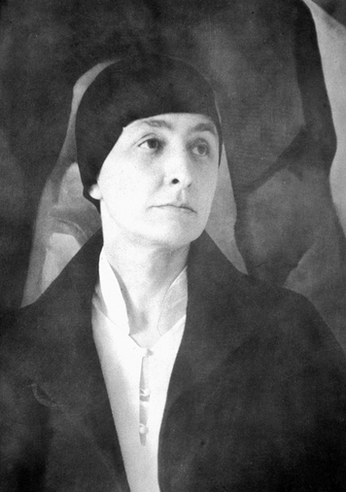
This land here cost twenty lives a foot that summer . . . See that little stream—we could walk to it in two minutes. It took the British a month to walk it—a whole empire walking very slowly . . . leaving the dead like a million bloody rugs. No Europeans will ever do that again in this generation.
—F. Scott Fitzgerald, Tender Is the Night, 1933
Writers in the United States also found fault with American life. Sinclair Lewis's novel Main Street looked at the tedium and narrowness of life in small-town America. Playwright Eugene O'Neill wove dark, poetic tragedies out of everyday life. Both O'Neill and Lewis won the Nobel Prize for Literature.
Artists also used their work to portray modern life. Edward Hopper's paintings of New York City and New England towns express a sense of loneliness and isolation. Rockwell Kent, one of the most popular artists of this period, used tonal contrasts to create moody scenes of nature.
Georgia O'Keeffe also found inspiration in nature. She is famous for her paintings of huge flowers and, later, desert landscapes. O'Keeffe once said of her paintings, "Nobody sees a flower—really—it is so small it takes time—we haven't time—and to see takes time, like to have a friend takes time."

Exploring Culture Becomes a Popular Pastime
Americans responded to this explosion of culture with enthusiasm. Art museums displayed the works of new artists such as Hopper and O'Keeffe. Magazines also showcased popular art of the time.
The American public developed a growing interest in literature as well. Magazines and newspapers helped introduce new writers to a range of readers. In addition, two publishing innovations made books more available to readers. One was the paperback book, less expensive than hardback, clothbound books. The other was the book club. Founded in 1926, the Book of the Month Club distributed books by writers such as Hemingway to members by mail. The Book of the Month Club exposed millions of Americans to new books.

8. Sports Heroes Create a Country of Fans
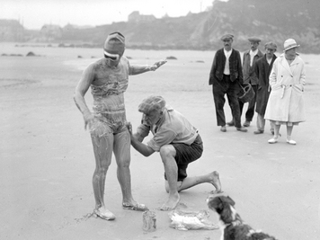
The year was 1926. No woman had ever swum across the English Channel. Many people doubted that a woman could, but Gertrude Ederle, an American swimmer, was about to try. Ederle had already won Olympic medals in 1924. She had also already tried to swim the channel but had failed. In this attempt, she succeeded. Ederle not only swam across the 35-mile channel. She also beat the men's record by nearly two hours. Upon her return to the United States, Americans greeted Ederle with a ticker-tape parade through New York City.

Spectator Sports Become Big Business in the 1920s
By the 1920s, the eight-hour workday, five-day workweek had become the rule in many industries. More leisure time freed Americans to pursue interests beyond work. Economist Stuart Chase estimated that Americans spent one fourth of the national income on play and recreation. Some of this money went toward spectator sports, or sports that attract large numbers of fans who attend games.
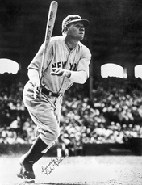
Sports became a big business. Professional baseball and football teams attracted legions of loyal fans. Boxing and wrestling matches also attracted crowds. The promoter of the 1921 boxing match between U.S. heavyweight champion Jack Dempsey and French challenger Georges Carpentier built a 60,000-seat stadium for the event. Ticket sales hit $1.8 million, more than any previous boxing match. When Dempsey fought to regain his title from Gene Tunney in 1927, more than 100,000 people bought tickets worth $2,658,660—a record at that time.
The mass media helped raise the public interest in sports. Millions of Americans listened to radio broadcasts of popular sporting events. One entrepreneur even figured out a way to add "live action" to a radio broadcast. He had a blow-by-blow radio broadcast of the 1927 Dempsey-Tunney match piped into a large hall while two local boxers reenacted the fight for the audience.

Sports Stars Become National Celebrities
Before the 1920s, the light of publicity had never shone so brightly on sports figures. Now Americans wanted to know everything about their favorites. The media gladly fed this passion.
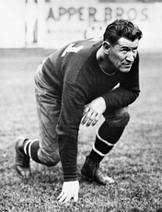
The most famous sports celebrity of this era was baseball slugger Babe Ruth, the legendary "Sultan of Swat." In the 1927 season, Ruth hit 60 home runs, a record that would remain unbroken for 34 years. Ruth attracted so many fans that Yankee Stadium, which opened in 1923, was nicknamed "the House That Ruth Built."
Jim Thorpe, an American Indian, was one of the greatest all-around athletes. He began his sports career as an outstanding college football player. He won fame as an Olympic track and field champion, and then went on to play professional baseball and football. In 1920, Thorpe became the first president of the group that was to become the National Football League (NFL).
Women also made their mark on sports. Gertrude Ederle broke national and world swimming records on a regular basis. Tennis star Helen Wills won many tennis championships in the United States and Europe. She was known for her ability to hit the ball harder than any woman she faced and for a calm manner that earned her the nickname "Little Miss Poker Face."

Summary
New ideas and prosperity brought change to American popular culture in the Roaring Twenties. The creative energy of writers, artists, filmmakers, and musicians, as well as innovations by businesspeople and inventors, all contributed to new directions in American life.
Consumer culture New products and advertising encouraged a buying spree. Credit and installment buying allowed people to buy now and pay later.
Mass media National magazines, radio, and motion pictures brought news, information, and entertainment to millions of Americans. Regional differences began to fade as a new national popular culture became part of daily life.
Women voters All women gained the vote in 1920. The League of Women Voters encouraged all voters to become informed about public issues. Congress considered, but rejected, the first version of the equal rights amendment.
The Jazz Age Jazz, a new form of music, expressed the mood of the decade. Introduced by African American musicians, jazz became popular throughout the country and the world.
Harlem Renaissance Musicians and writers centered in Harlem gave voice to the experiences of African Americans in song, poetry, and novels.
Lost Generation Disillusioned by World War I and the nation's growing consumer culture, some artists and writers fled to Paris. This "Lost Generation" produced books and poetry that are still read and enjoyed today.
Spectator sports More leisure time allowed Americans to attend sporting events. Spectator sports became a big business, and athletes became national celebrities.

