IMPERIALISM: LATE 19TH CENTURY MANIFEST DESTINY?

Definition of manifest destiny:

I. Read each of the quotes below. What is the quote saying about the reasons for American expansionism in the period before the Civil War?

Quote | Author’s point of view about manifest destiny and the reasons for its support or rejection
1. Andrew Burnaby (British clergyman and traveler who wrote, Travels Through the Middle Settlements in North America, In the Years 1759 and 1760) said in 1775, the year before the Declaration of Independence was signed)
“An idea, strange as it is visionary, has entered into the minds of the generality of mankind, that empire is travelling westward; and everyone is looking forward with eager and impatient expectation to that destined moment when America is to give law to the rest of the world.”
2. Thomas Jefferson wrote in 1801: “However our present interests may restrain us within our own limits, it is impossible not to look forward to distant times, when our rapid multiplication will expand itself beyond those limits, and cover the whole northern, if not the southern continent, with a people speaking the same language, government in similar forms, and by similar laws. . .”
3. Representative John A. Harper of New Hampshire wrote in 1812, on the eve of the War of 1812:
“To me, sir, it appears that the Author of Nature has marked our limits in the south, by the gulf of Mexico; and on the north by the regions of eternal frost (the Arctic).”
4. Niles Weekly Register, popular American magazine, 1819:
“Florida will just as naturally come into our possession as the waters of the Mississippi seek the sea; and anything done to obstruct the operation will be as useless, in the end, as an attempt to arrest and turn back the course of that mighty stream.”
5. Robert Winthrop, U.S. Congressman, in the debate over Oregon, 1845:
“The Rocky Mountains are mere molehills. Our destiny is onward.”
6. James Buchanan, Secretary of State and future president, 1846: “Destiny beckons us to hold and civilize Mexico.”
7. Public Ledger, Philadelphia newspaper, 1853: “America is bounded on the East by the sunrise, West by the sunset, North by the Arctic Expedition, and South as far as we darn please.”
8. Paddy Chayefsky, twentieth century author/playwright who died in 1981:
“It’s not greed and ambition that makes wars – it’s goodness. Wars are always fought for the best of reasons, for liberation or manifest destiny, always against tyranny and always in the best interests of humanity. So far this year, we’ve managed to butcher some 10,000,000 people in the interest of humanity. The next war, it seems we’ll have to destroy all of man in order to preserve his damn dignity.”

II. American Progress by John Gast (1872)

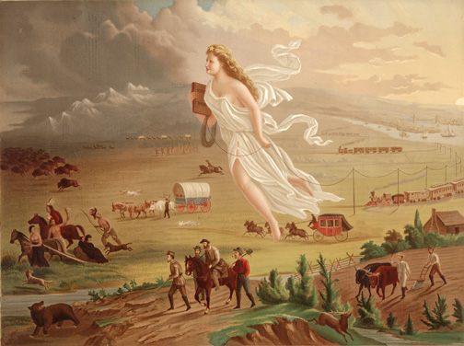

Answer the following questions:
- Briefly explain the point of view expressed by the artist about either MIGRATION, TECHNOLOGY, OR AMERICAN INDIANS.
- Briefly explain ONE development from the period 1800 to 1845 that led to the point of view expressed by the artist.
- Briefly explain ONE way in which developments in the period after 1845 challenged or supported the point of view expressed by the artist.

Definition of Imperialism:

III. Read each of the quotes below. What is the author’s point of view regarding late 19th century expansion?

Quote | Author’s Point of View about late 19th century expansionism/imperialism and the reasons for its support or rejection
1. Josiah Strong, U.S. clergyman, 1885:
“This powerful race (White, Protestant Americans) will move down upon Mexico, down upon Central and South America, out upon the islands of the sea, over upon Africa and beyond . . . Is there room for reasonable doubt that this race. . . is destined to dispossess many weaker races, assimilate others, and mold the remainder, until, in a very true and important sense, it has Anglo-Saxonized mankind?”
2. William McKinley, U.S. President, 1898: “We need Hawaii just as much and a good deal more than we did California. It is manifest destiny.”
3. Senator Mason of Illinois, 1898:
“Where is the ambitious Senator who wants to make laws at this desk to govern people 10,000 miles away? Who is the kind-hearted statesman? You cannot speak their language. You do not know their religion. Why, I never even saw one of their newspapers.”

IV. Is imperialism the same policy as manifest destiny? How are imperialism and manifest destiny similar; how are they different? Identify at least 3 similarities and 3 differences including reasons for and results of each.

SIMILARITIES | DIFFERENCES
1.  2.  3. | 1.  2.  3.

V. Why did the United States embark on its imperialist endeavors at the end of the 19th century and the beginning of the 20th century, rather than 50 years earlier or 50 years later?
Why were conditions ripe for imperialism between 1890 and 1900. Working with members of your group, list 10 reasons why the U.S. became an imperialist nation in the late 1890s and not earlier or later.

1.

2.

3.

4.

5.

6.

7.

8.

9.

10.

VI. Assessment: Imagine that Gast’s painting, “American Progress,” was painted in the early twentieth century rather than in 1872. Describe 5 ways that the painting might have been different.

Thematic Learning Objective: WOR 2.0 Analyze the reasons for and results of U.S. diplomatic, economic, and military initiatives in North America and overseas.
Analyze the reasons for and results of U.S. diplomatic, economic, and military initiatives in North America and overseas.

