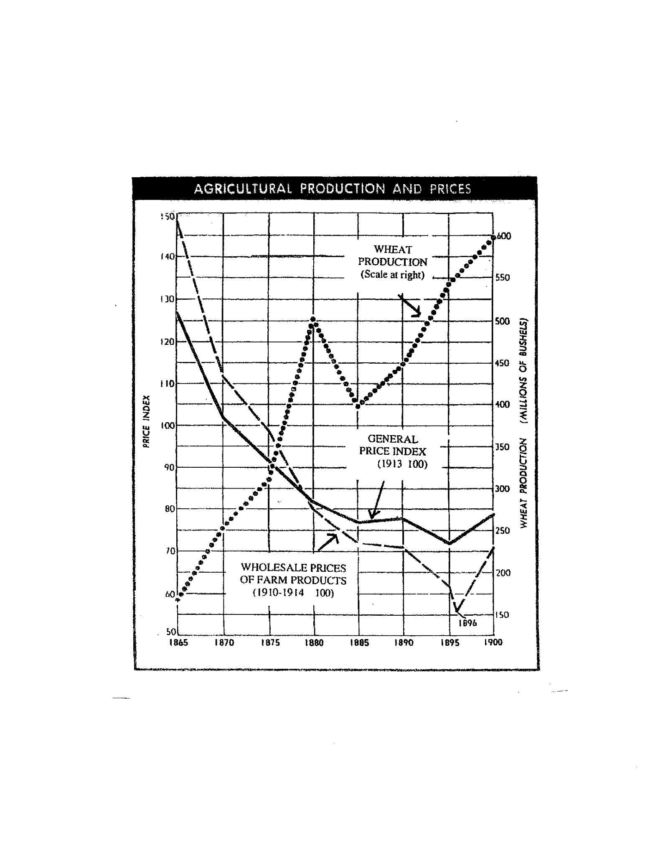
What happened to general prices in the late 19th century?
What happened to wheat production?
What happened to the wholesale prices for farm products?
To what do you attribute the decline in farm prices during this period? (overproduction)
How would you describe the economy of the late 19th century? Who suffered during this type of economy? Who prospered?
What happened to wheat production between 1895 and 1900?
What happened to prices for farm products during this 5 year period?
Why do you think prices rose from 1895-1900 despite the fact that production was increasing?

